CS 340 README Template
This project is an exercise in developing a CRUD module in python that create, reads, updates, and deletes data in a mongo database. The module itself logs into the database using given credentials, which are hard coded into the AnimalShelter class then allows the user to Create, Read, Update, and Delete, animals the Austin Animal Control (aac) database.

This project is an exercise in creating and manipulating a database using OOP, specifically a noSQL database using a python module.

To get this project running, follow these steps.
- Open Codio module.
- Import Austin Animal Control CSV file into MongoDB and name the database aac.
- Use Admin database to create user credentials with read/write permissions in the database.
- Ensure aac database with user credentials are imported.
- Run MongoDB in your virtual environment.
- Open Jupyter Notebook in Codio.
- Run the ModuleFourTestScript.

- Python 3
- MongoDB
- PyMongo

Code Example
#This method creates new data to import into the database.
def create(self, data):
if data is not None:
self.database.animals.insert_one(data) # data should be dictionary
return True
else:
return False

#This method reads data from the database.
def read(self, query):
if query is not None:
data = self.database.animals.find(query)
return list(data)
else:
return[]

#This method updates data in the database
def update(self, query, updatedInfo):
if query is not None and updatedInfo is not None:
result = self.database.animals.update_many(query, {"$set": updatedInfo})
return result.modified_count
else:
return 0
#This method deletes data from the database
def delete(self, query):
if query is not None:
result = self.database.animals.delete_many(query)
return result.deleted_count
else:
return 0

In the tests, we import our CRUD module and instantiate an instance of our class, we give sample data to import into the database using the create() function with this code, then run a print statement to ensure the data was created.

from CRUD_Python_Module import AnimalShelter

animal = AnimalShelter() #user credentials are hardcoded into the py module.

create_data = {
'age_upon_outcome' : "2 years",
'animal_id' : "D1234",
'animal_type': "Dog",
'breed' : "Pit Bull",
'color' : "Grey",
'date_of_birth' : "unknown",
'datetime': "2026-03-24 02:29pm",
'monthyear':"March, 2026",
'name': "TravisErwinTestDog",
'outcome_subtype': " ",
'outcome_type': "Adoption",
'sex_upon_outcome': "Neutered Male",
'location_lat': "",
'location_long': "",
'ageu_upon_outcome_in_weeks': 104 as well as read data from the database.
}
print("New Animal:", animal.create(create_data))

Next we test the read() function by querying the database using the new animal name as a key, printing out the data of the new animal.

results = animal.read({'name':"TravisErwinTestDog"})

print("Read results:")
for doc in results:
print(doc)

Next we test the update() function by querying an animal by a key value then changing values in the data, then returning the updated animal.
updated_count = animal.update({'name':"TravisErwinTestDog"},
{'age_upon_outcome':"3 years",
'date_of_birth':"July 4, 2023",
'animal_id':"D12345"})

print(animal.read({'name':"TravisErwinTestDog"}))

Then we test the delete() function by removing an animal from the collection using a key value and returning the number of animals removed from the collection.
deleted = animal.delete({'name':"TravisErwinTestDog"})

print(deleted, "animal(s) has/have been removed from the collection.")

Screenshots
Screenshot showing successful import of the csv file. 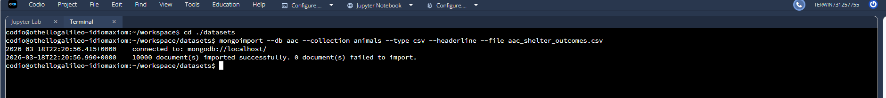

Image showing creation of new user account.
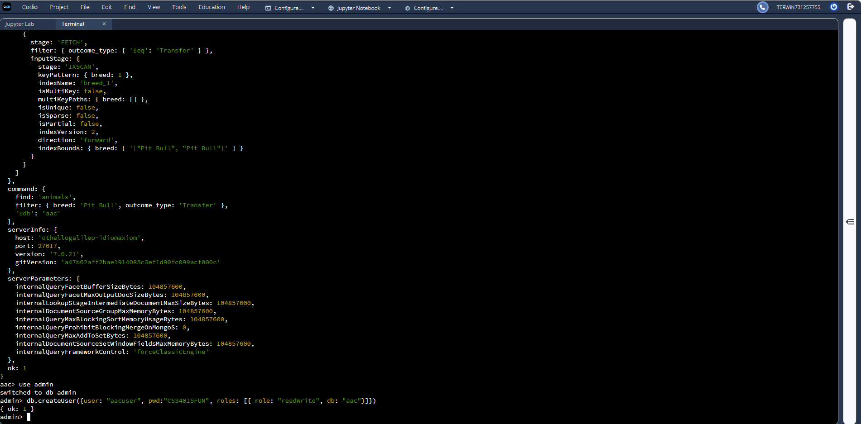
Image showing login was successful and verification of login as specified user. 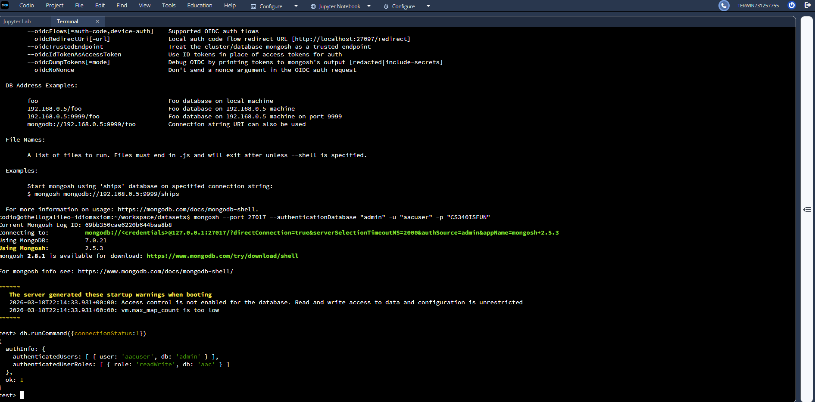

Image showing creation of an animal in the database
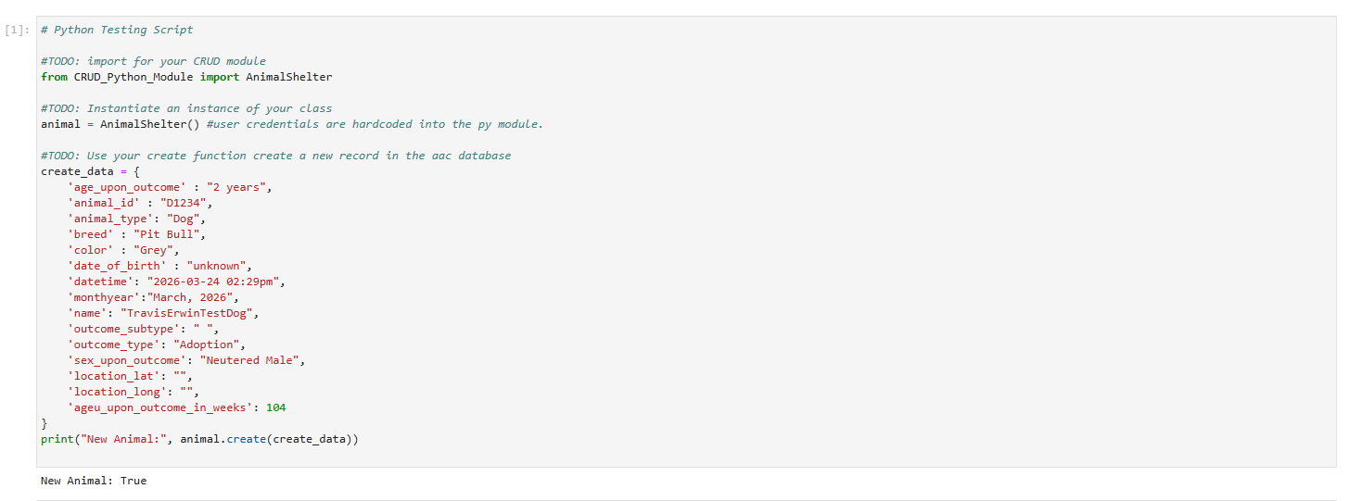
Image showing Read, Update, and Deletion of an animal in the database 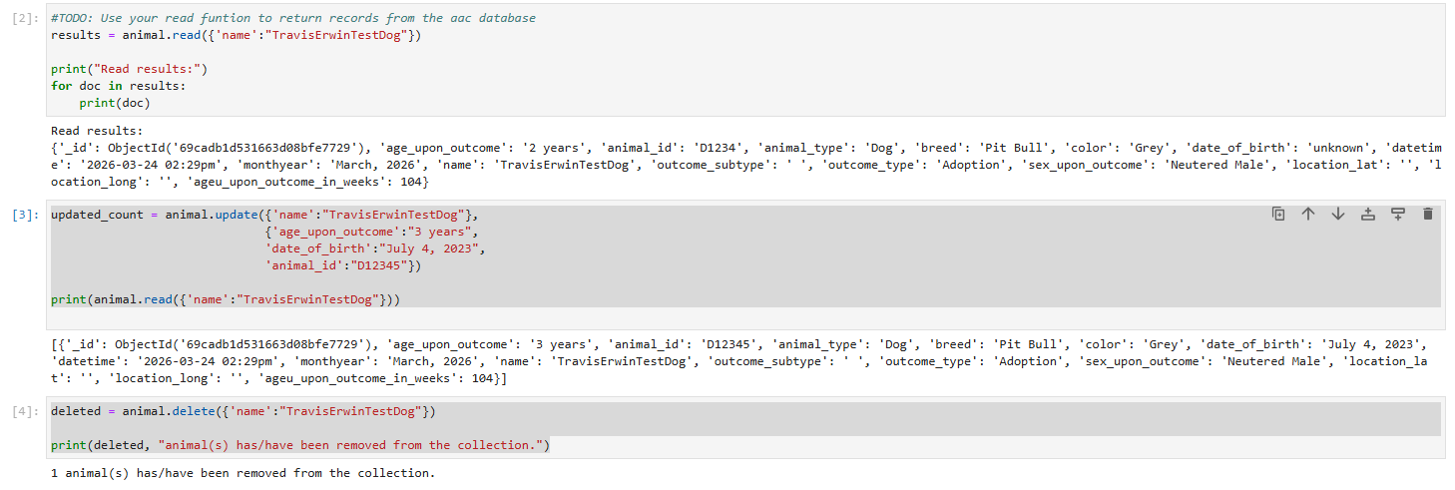

Contact
Your name: Travis Erwin

